**How to Install Soft Keyboard**

This tutorial tests with "2016-05-27-raspbian-jessie" version, if you want to use wheezy or an earlier version of the image, there are differences in the fifth and sixth step file path, you can have a reference of virtual-keyboard on office installation tutorials

Official reference address (English)

<http://ozzmaker.com/virtual-keyboard-for-the-raspberry-pi/>

1. Install the necessary files

sudo apt-get update

sudo apt-get install libfakekey-dev libpng-dev autoconf libxft-dev libtool automake -y

2.Install the virtual keyboard “matchbox-keyboard”

git clone https://github.com/mwilliams03/matchbox-keyboard.git

cd matchbox-keyboard

./autogen.sh

Note: "./autogen.sh" execution time needs about a few minutes,It will shows as picrtured after correct implementation. If not similiar as pictured after implementation, you need check if there are error tips

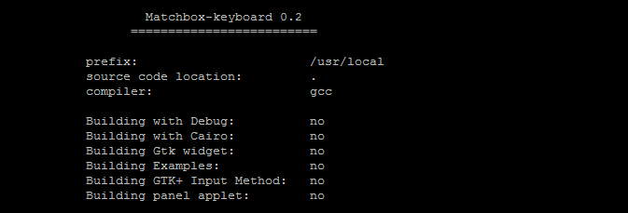

Then execute:

sudo make

sudo make install

3.Shared library for installing virtual keyboard

sudo apt-get install libmatchbox1 –y

As pictured:

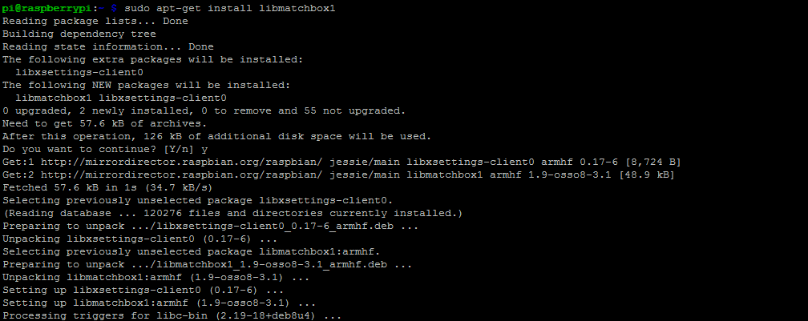

4.Create a virtual keyboard to start the script

sudo nano /usr/bin/toggle-matchbox-keyboard.sh

Paste the below text and press ctr+x and Y, save and exit

#!/bin/bash

#This script toggle the virtual keyboard

PID=`pidof matchbox-keyboard`

if [ ! -e $PID ]; then

killall matchbox-keyboard

else

matchbox-keyboard -s 50 extended&

fi

Add executable permissions for the above script

sudo chmod +x /usr/bin/toggle-matchbox-keyboard.sh

5.Add the script to the start menu

sudo nano /usr/share/applications/toggle-matchbox-keyboard.desktop

Paste the below text and press ctr+x and Y, save and exit

[Desktop Entry]

Name=Toggle Matchbox Keyboard

Comment=Toggle Matchbox Keyboard

Exec=toggle-matchbox-keyboard.sh

Type=Application

Icon=matchbox-keyboard.png

Categories=Panel;Utility;MB

X-MB-INPUT-MECHANSIM=True

6. Create icons On the taskbar (note that this steps must use "Pi" user rights, if with administrator privileges, you will not find this file)

nano ~/.config/lxpanel/LXDE-pi/panels/panel

7.Find similiar command with the following (different raspberry version may have different default content)

Plugin {

type=launchbar

Config {

Button {

id=/usr/share/applications/lxde-x-www-browser.desktop

}

Button {

id=/usr/share/raspi-ui-overrides/applications/pcmanfm.desktop

}

Button {

id=/usr/share/raspi-ui-overrides/applications/lxterminal.desktop

}

Button {

id=/usr/share/applications/wolfram-mathematica.desktop

}

Button {

id=/usr/share/applications/wolfram-language.desktop

}

}

}

Add the following code to add an icon item

Button {

id=toggle-matchbox-keyboard.desktop

}

The following picture are the effect after Modification

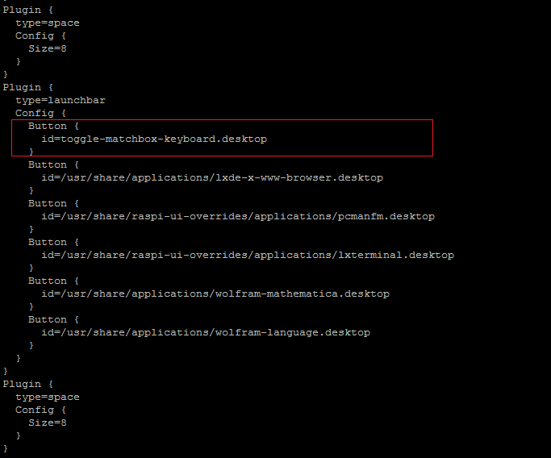

8.Execute the following command and restart after modification,if successfully, you can see a virtual keyboard Icon on the taskbar of screen.

sudo reboot

P.S.Change the size of the virtual keyboard by logining in SSH

DISPLAY=:0.0 matchbox-keyboard -s 50 extended

DISPLAY=:0.0 matchbox-keyboard -s 100 extended